# UiPath Studio (Community Edition) – As Offline Automation/RPA (MS-Flow Option)

# Getting Started

You have downloaded, installed the UiPath Studio (Community) and were able to create a new process and have a SharePoint online site for this sample with sample-set of documents having some images embedded in each file (Word/PDF)….

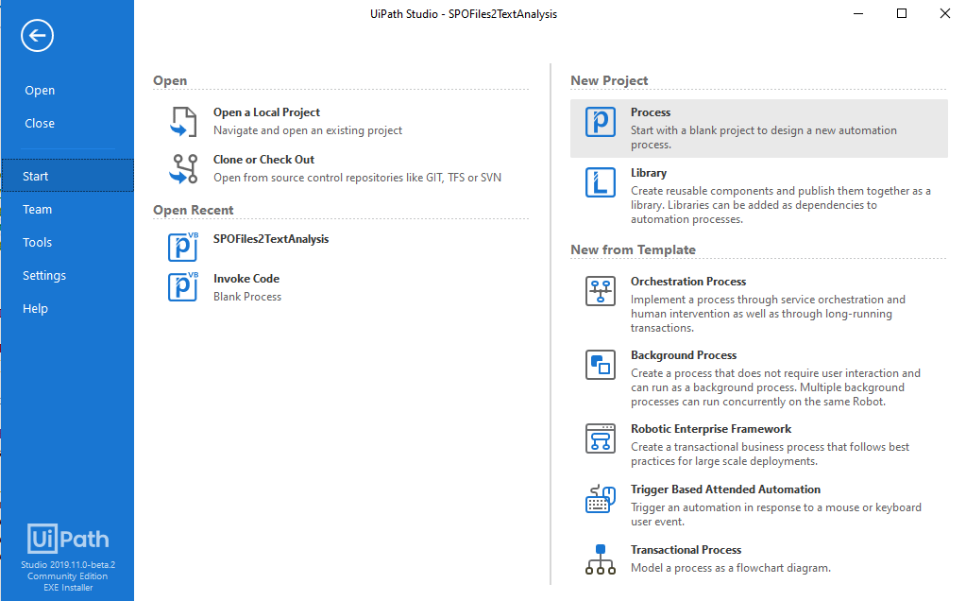 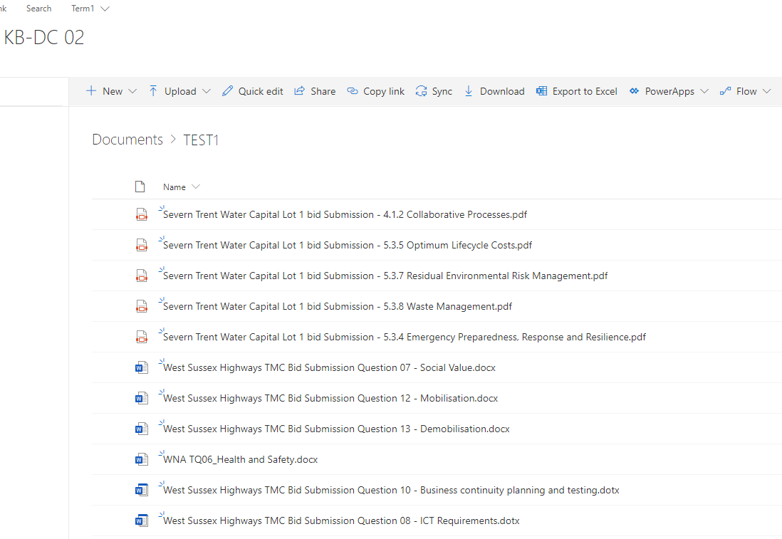

# Workflow/Sequence Story

1. Login to a SharePoint online site
2. Access a path (Document Library)
3. Read all folders and Iterate each
4. Read all files within each-folder and process as follows,
   1. Declare multiple assignment/variables like ItemUrl, folderperfilePath
   2. For a MS-Word file use the Word-Application-Scope activity and additional scoped activities like, “Read Text” etc. and populate a”textinWordFile” variable and write2disk. Then, assign current-iteration file to be renamed and exported as PDF. Further, for sake of practice – use “Invoke Code” activity to extract embedded objects (Images) from Docx/MSWord files (Code renames docx to .zip/.cab and accesses folder structure within using .Net System.IO.Compression classes….
   3. Next sequence continues when a .pdf file is found to exist, and this is used a basis for further (common) processing
      1. “Read full PDF” as text in textInWordFile
      2. “Extract Images From PDF” (UiPath.PDF.Activities.ExtractImagesFromPDF) also extracts image assets from the document.
      3. Using some implementation “Prepare String to Analyze” extract summary and cleaned text into “text2cognitive” transient variable. Also, for further processing ensure word/bytes limit of Text Analytics service from AZURE Cognitive API
      4. Create UiPath.Web.Activities.HttpClient activity and construct REST/API call to Azure Cognitive service.
      5. Write output from Response (text2cognitive) to disk.

# Flow-run results

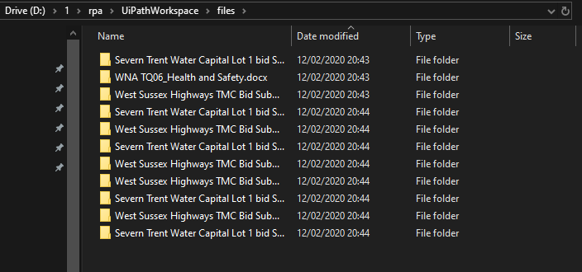

**------------------------------------------------------------------------------------------------------------------------------------------------------------------**

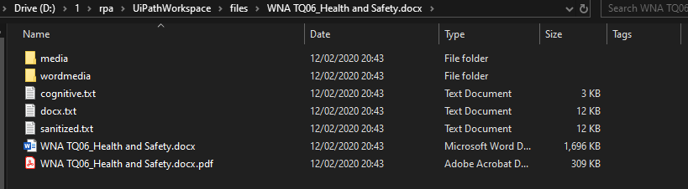

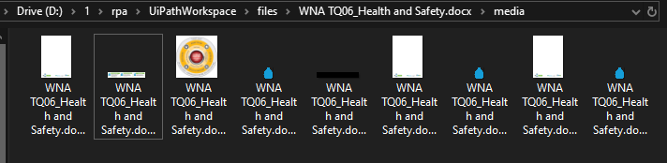

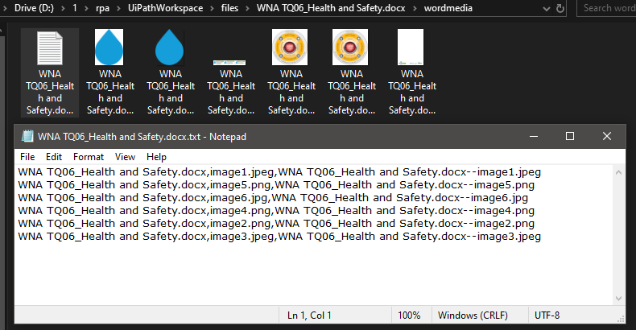

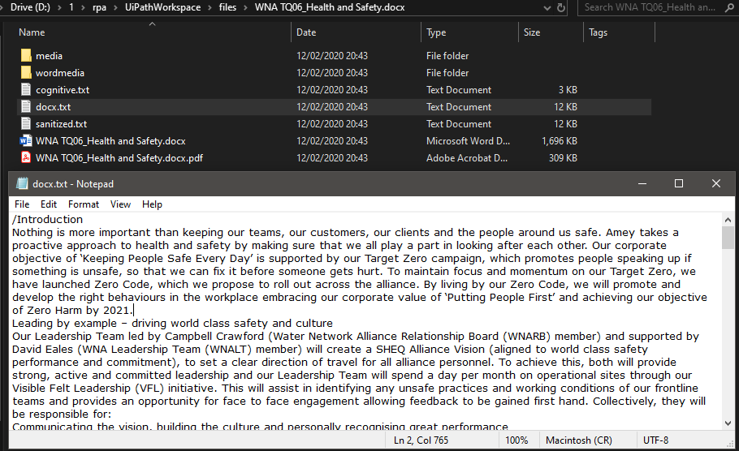

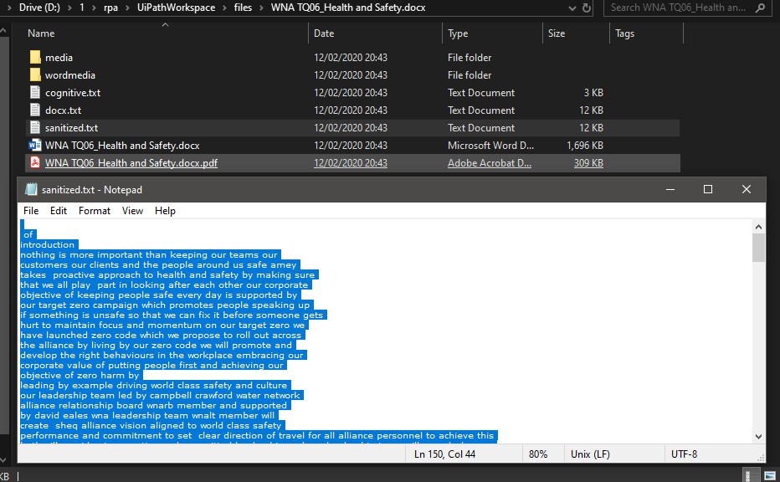

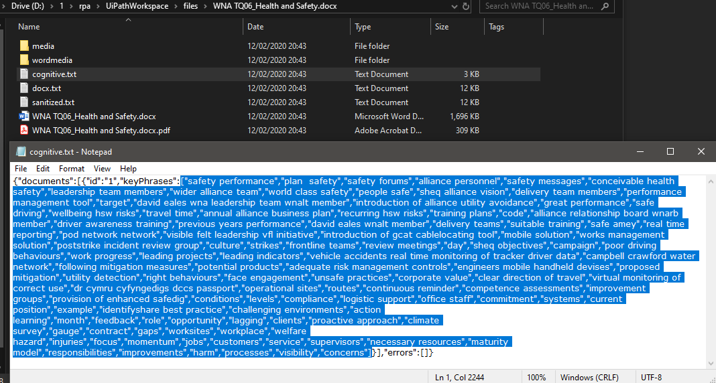

# Flow in Design studio

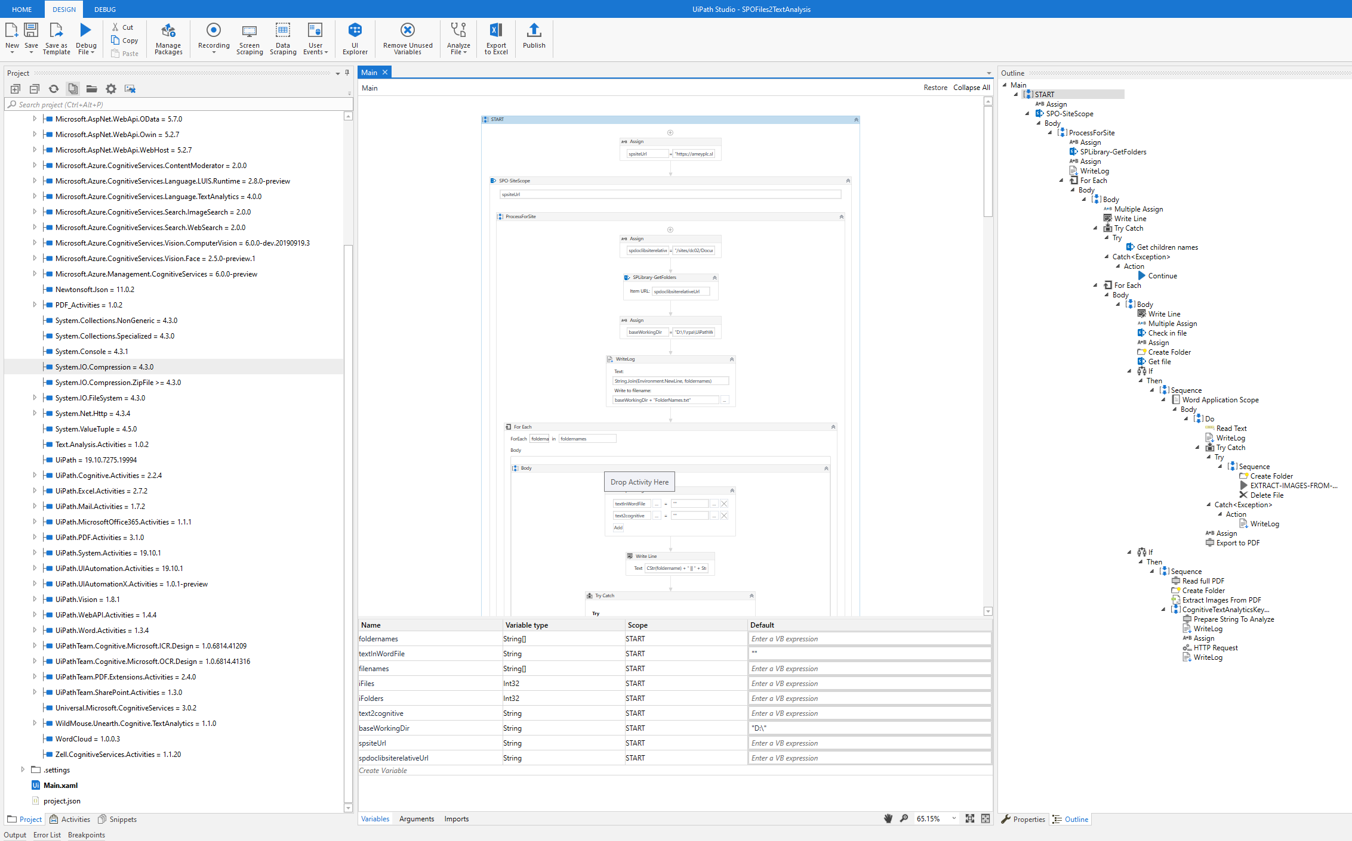

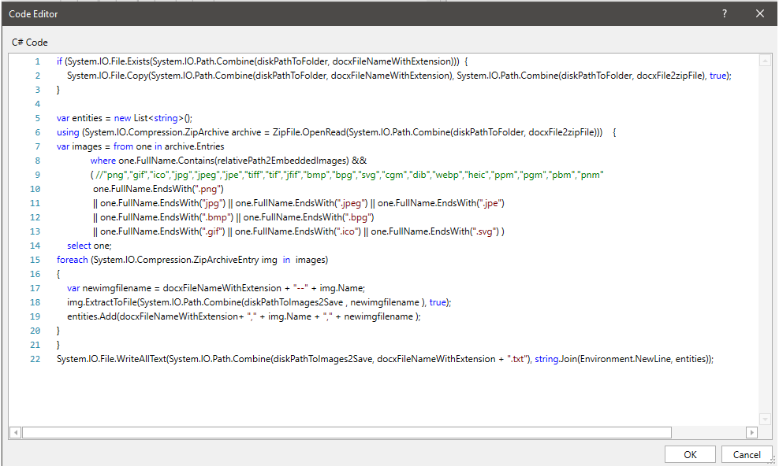

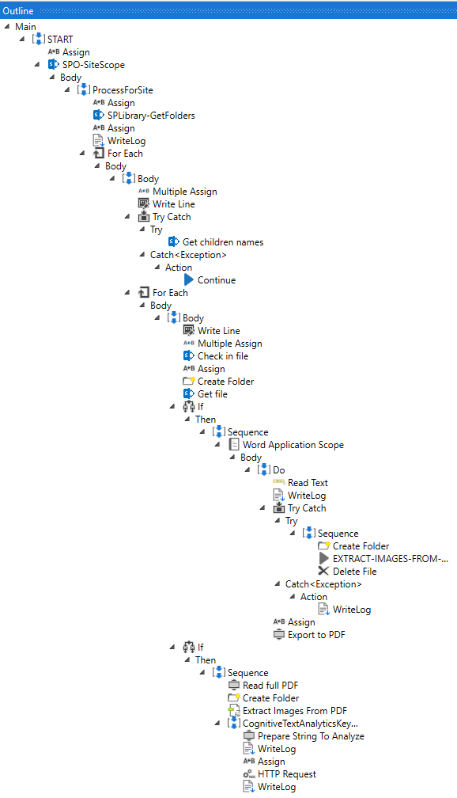

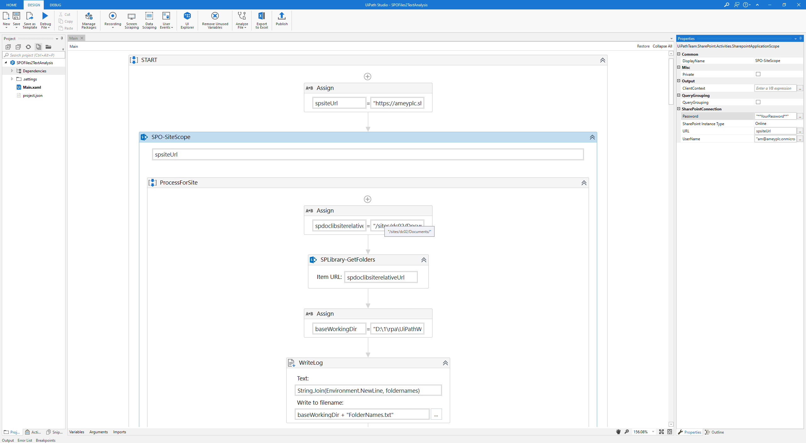

Get Files in Folders

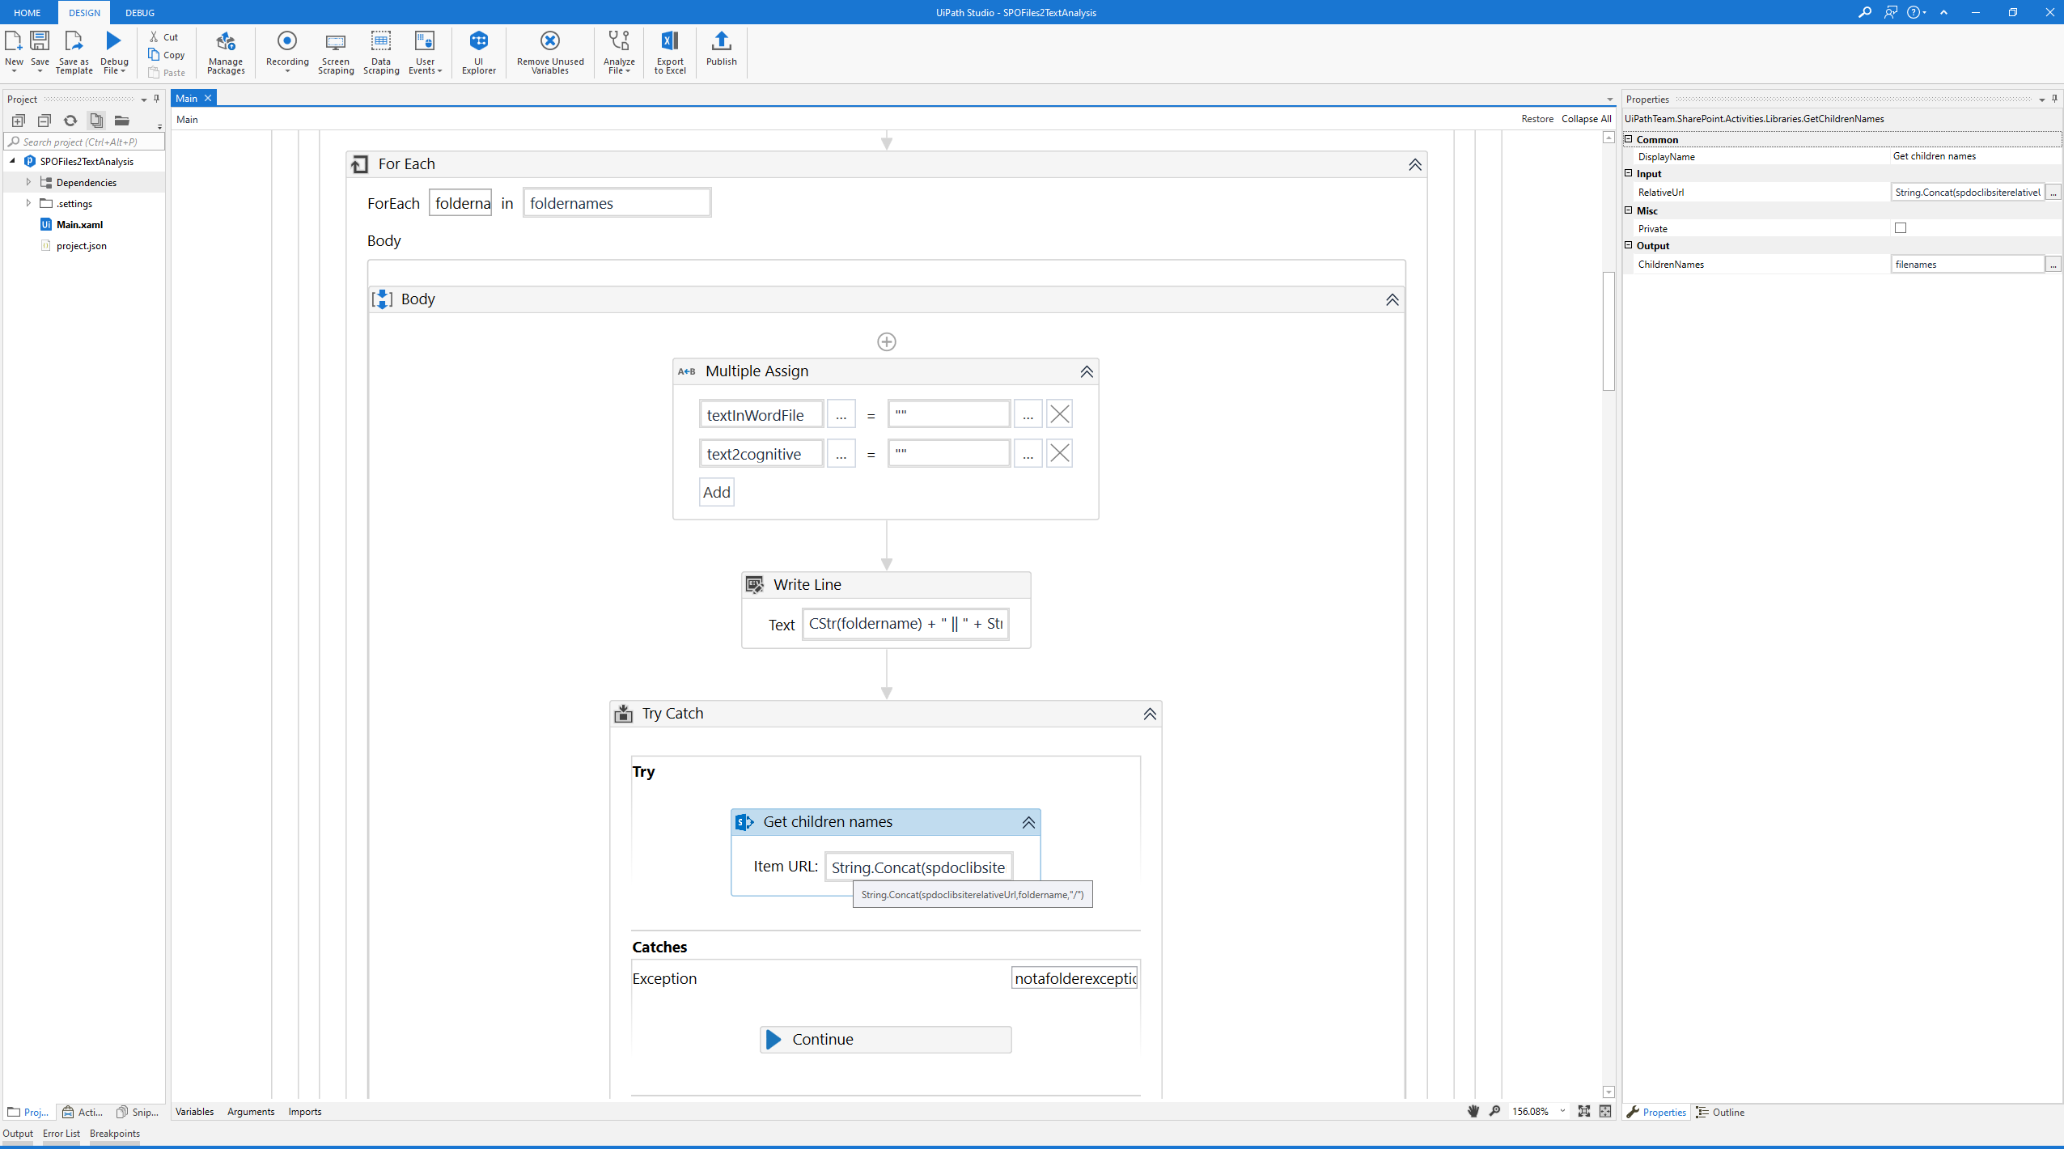

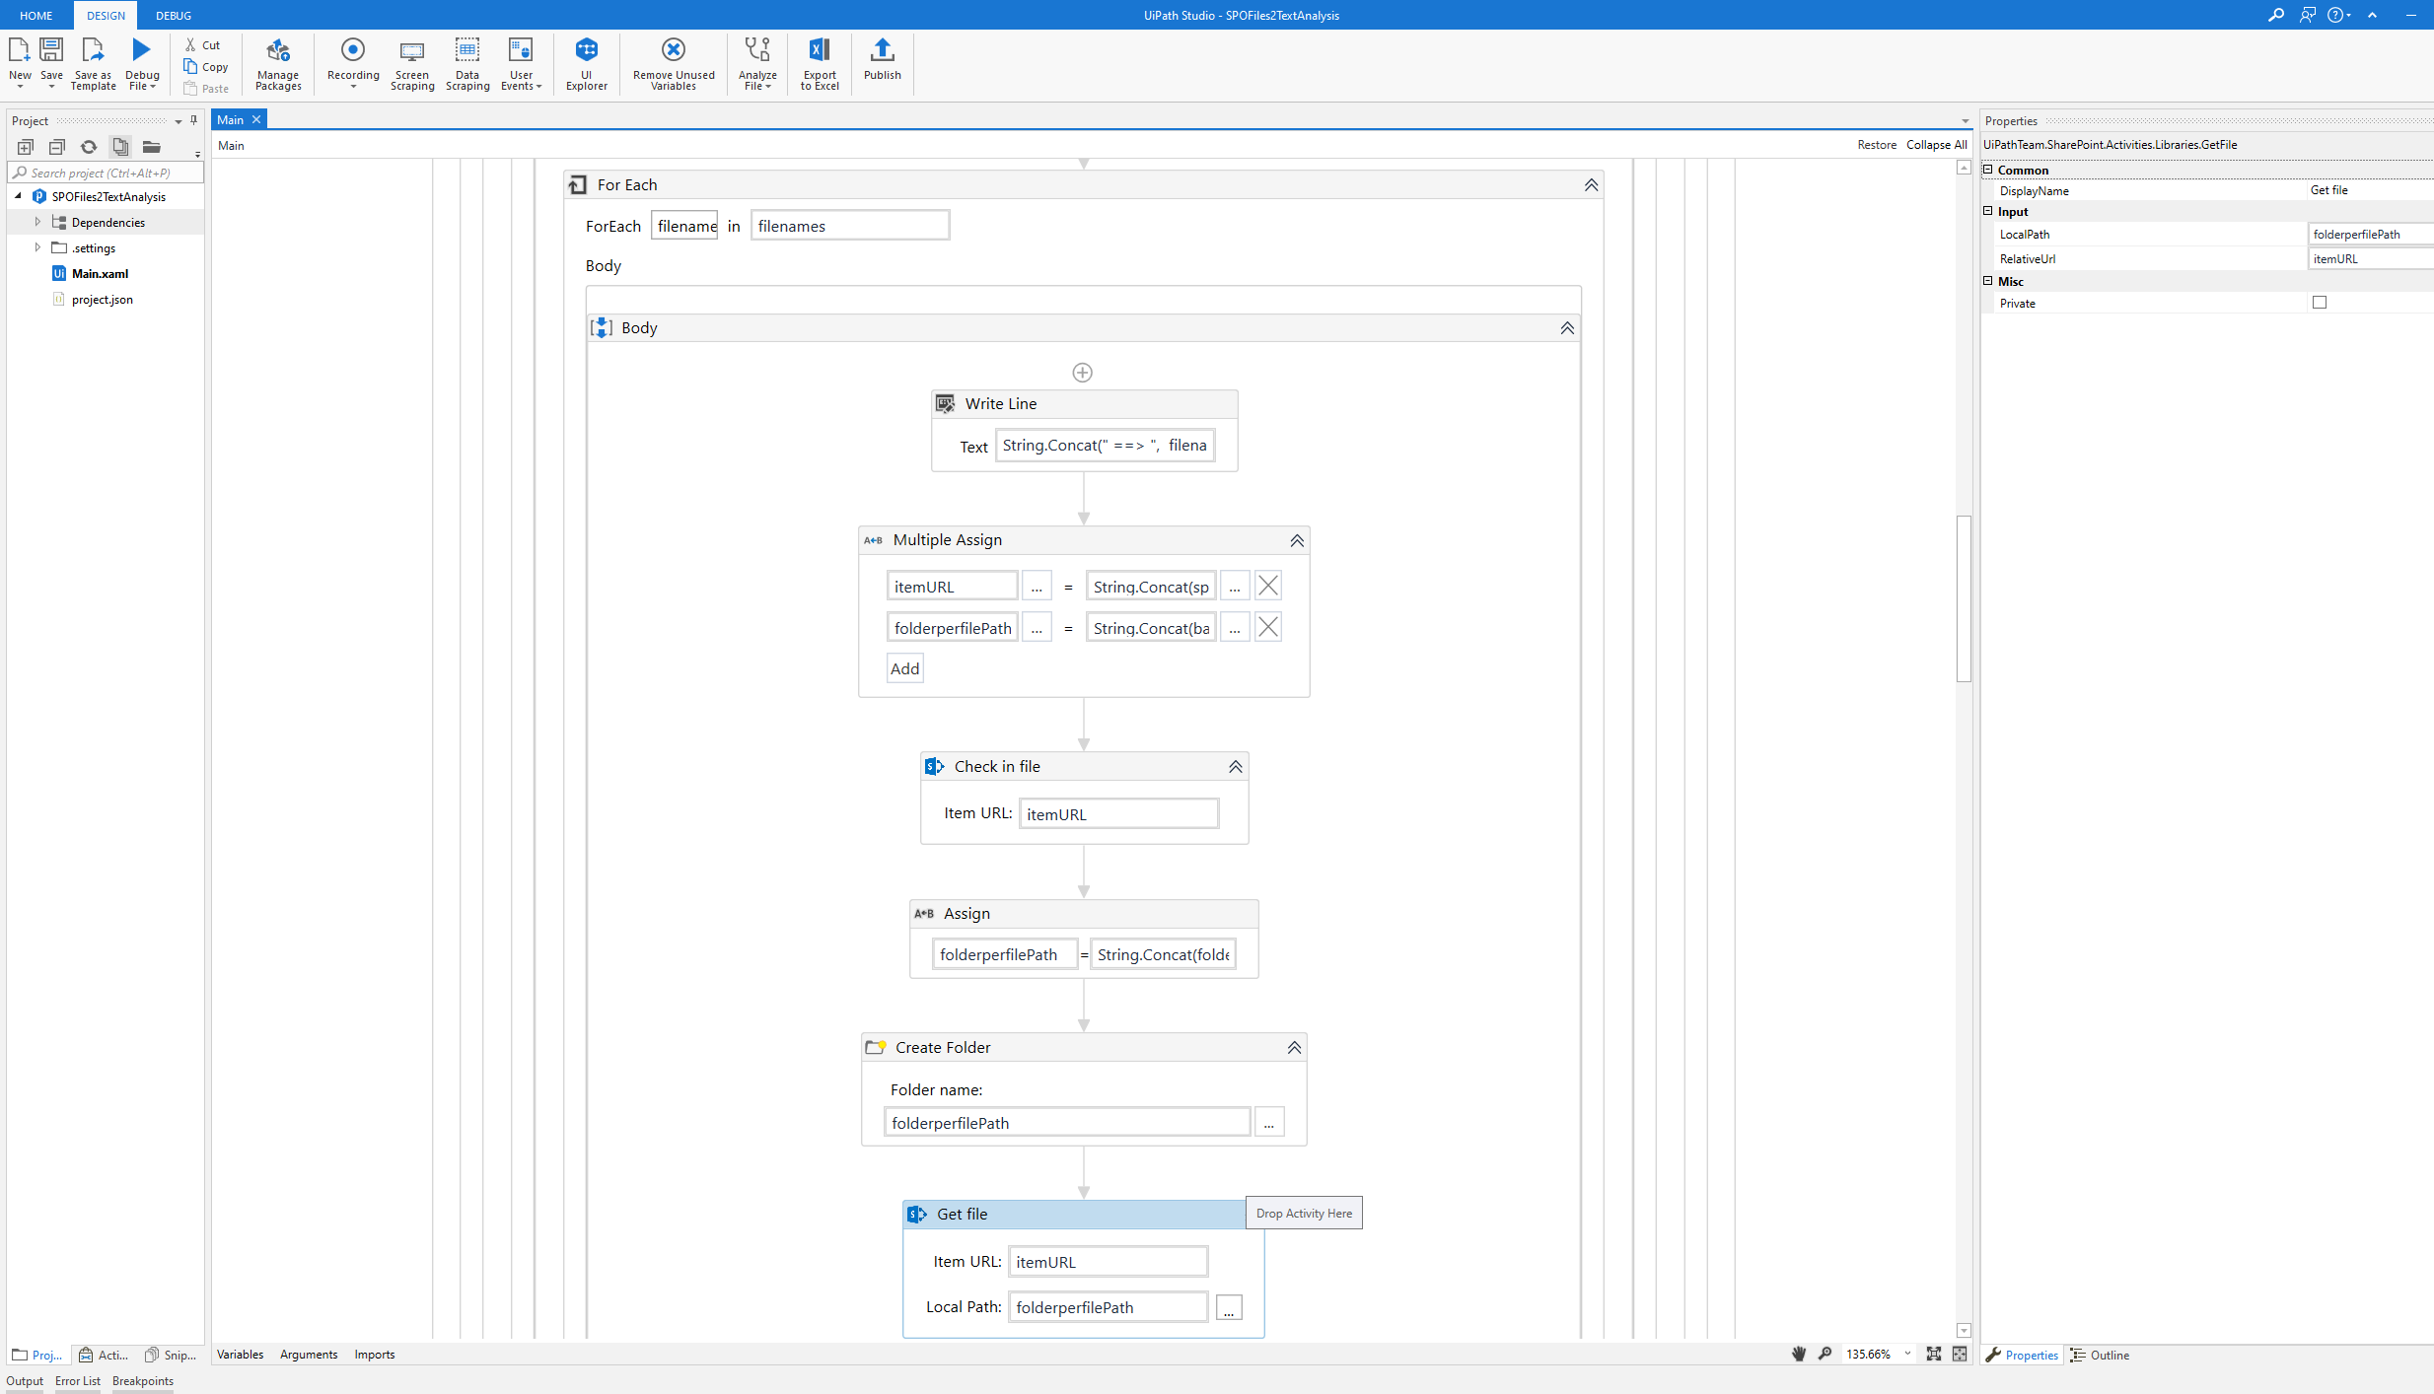

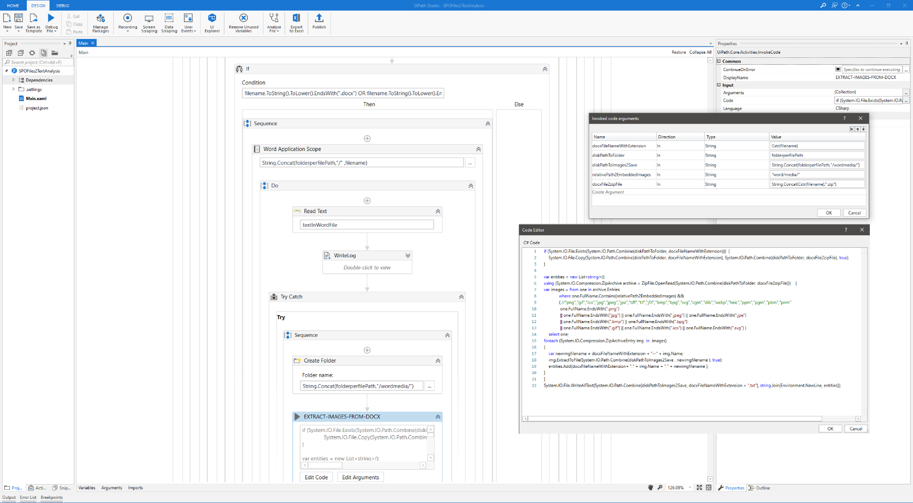

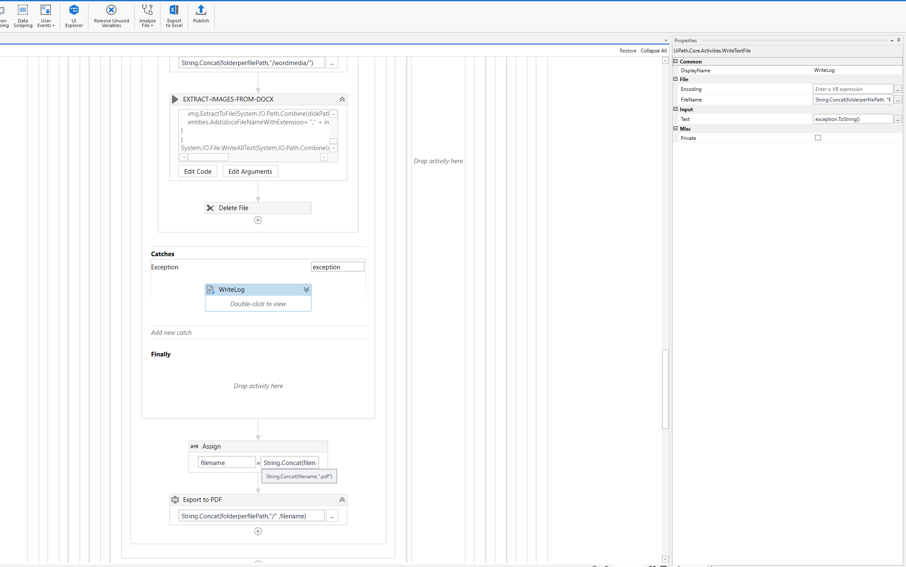

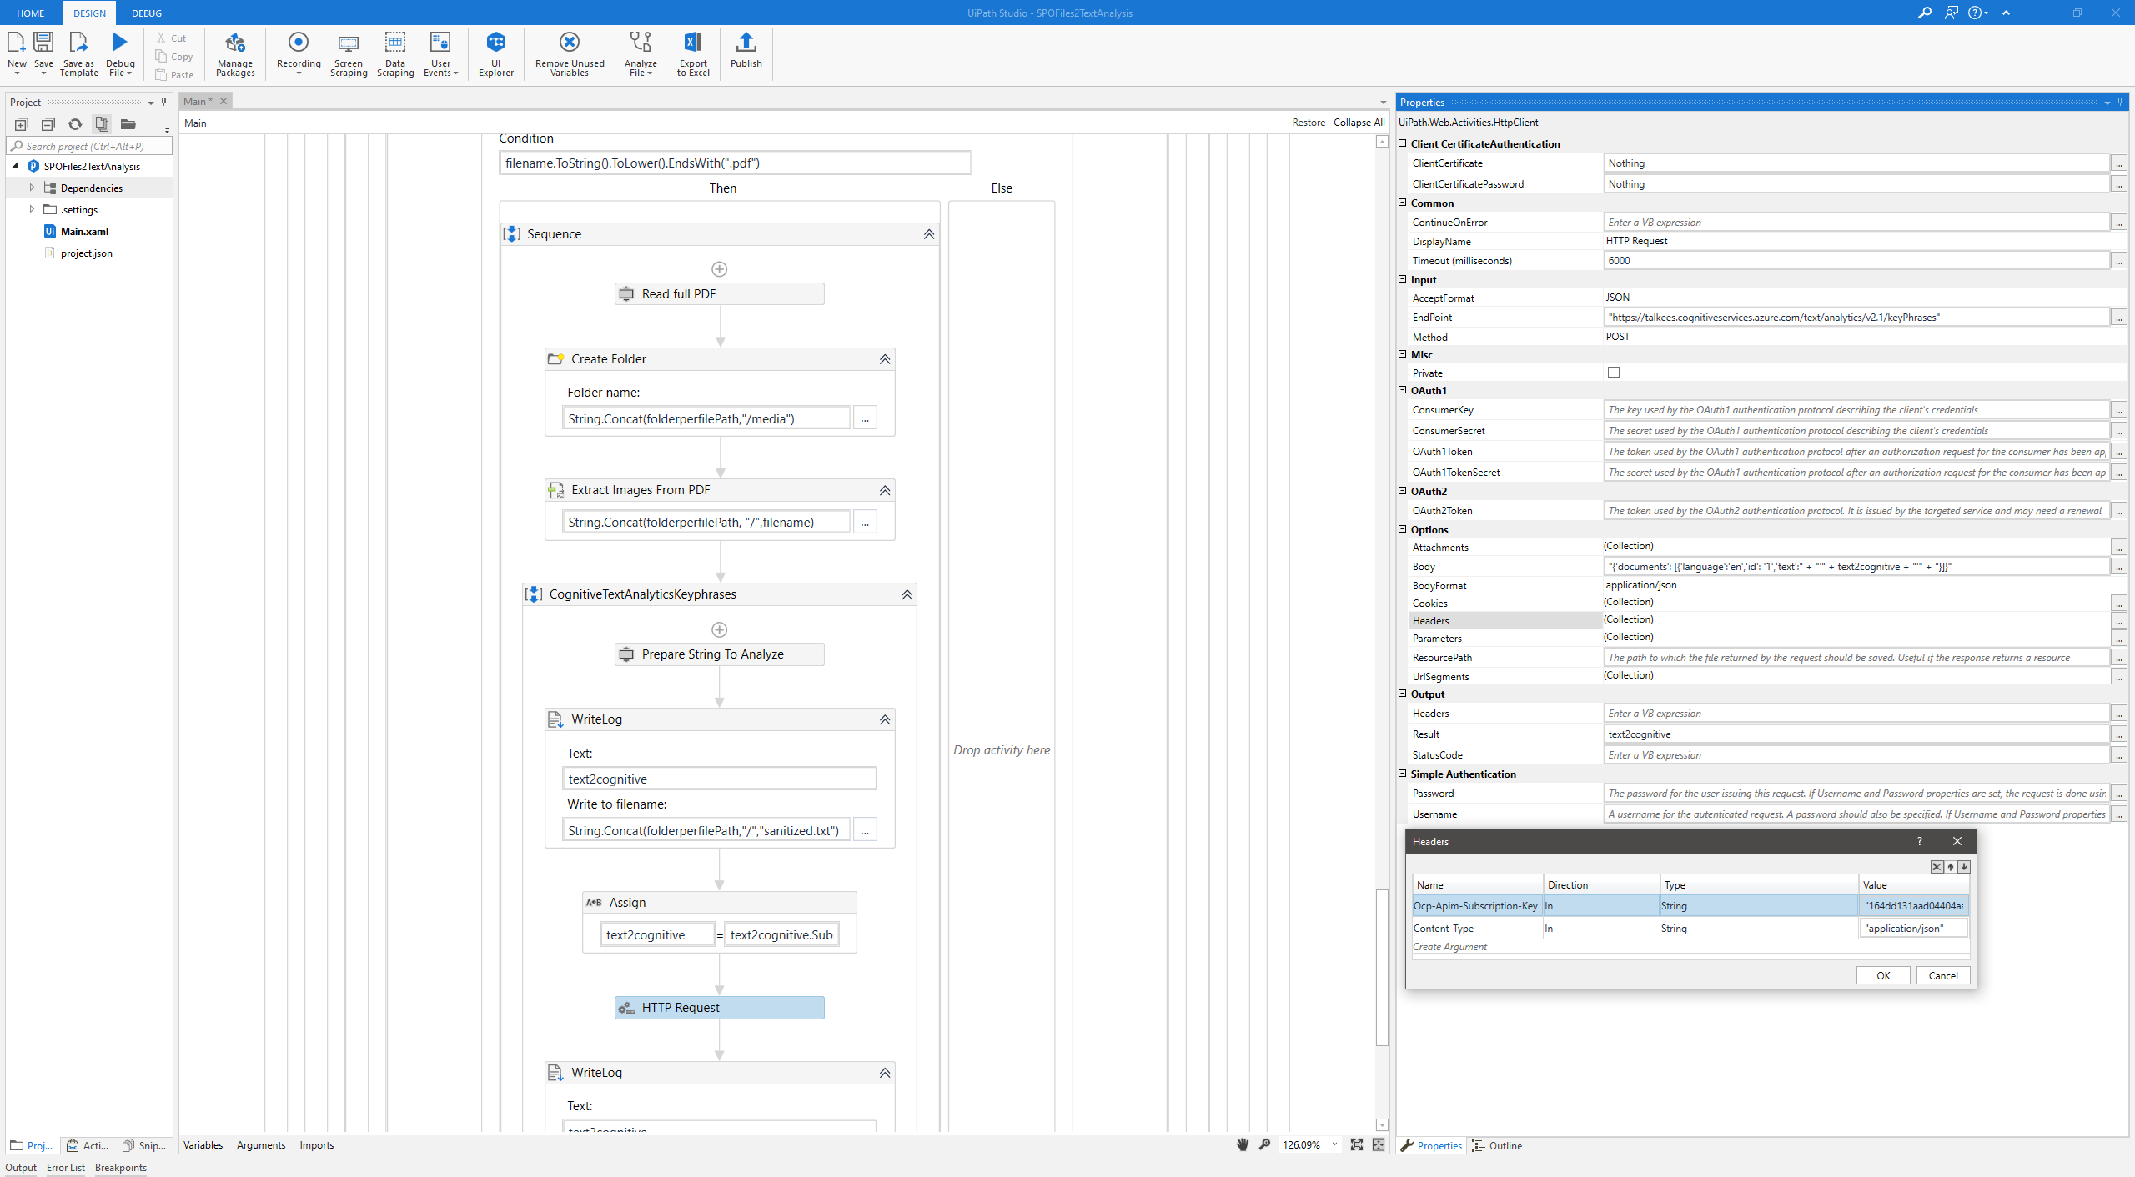

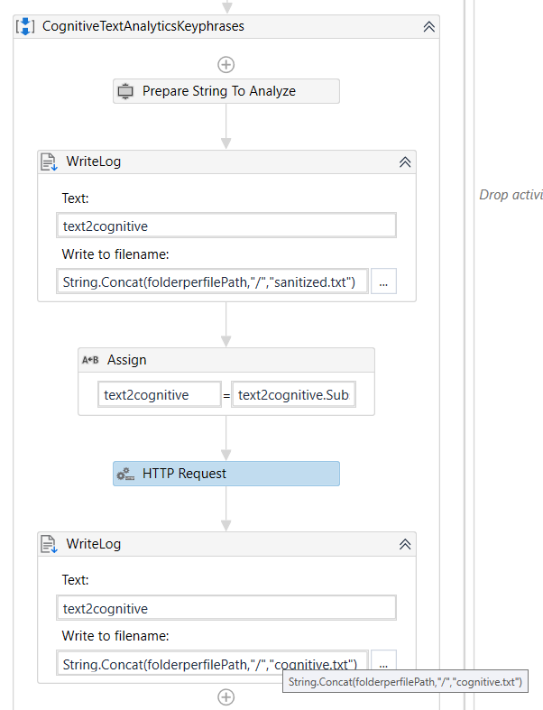 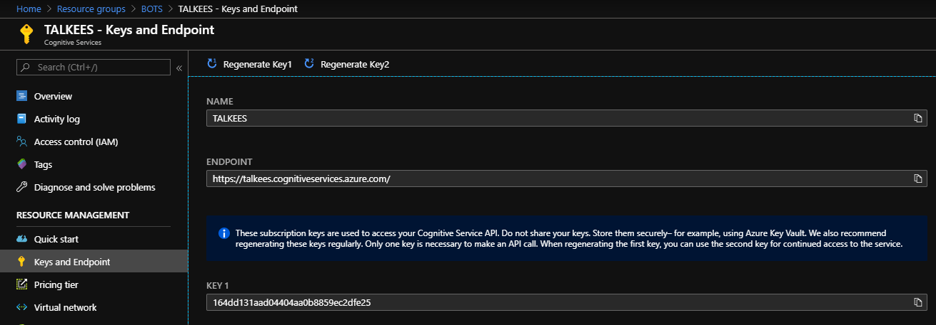

# Binaries & Bootstrap code etc…

 